1. Problem Statement
Process transaction tuples containing identifiers, amounts, and transaction types; detect invalid amounts or suspicious sequences using basic tuple unpacking.
2. Objectives
- Understand tuple structures and tuple unpacking in Python (id, amount, t_type).
- Use conditional checks to filter valid vs invalid transaction records.
3. Assumptions
- Transactions are stored in a list of tuples: (txn_id, amount, type).
- Amounts must be greater than $0$ to be valid.
4. Algorithm
- Start.
- Define a list of transaction tuples.
- Loop through the list, unpack each tuple into variables.
- Check if the amount is $≤0$; if so, flag it as invalid.
- Print audit report.
- Stop.
5.Flowchart
[Start]
--> [Define list of transaction tuples: (ID, Amount, Type)]
--> [Loop through each record in list]
--> [Unpack tuple into txn_id, amount, txn_type]
--> [Check condition: Is amount <= 0?]
├── Yes --> [Print ALERT: Invalid Transaction & increment invalid count]
└── No --> [Print SUCCESS: Valid Transaction & increment valid count]
--> [End of Loop]
--> [Print Total Valid and Invalid Summary] --> [Stop]
6. Pseudocode
START
transactions = [
("T101", 5000, "Deposit"),
("T102", -200, "Withdrawal"),
("T103", 1500, "Deposit")
]

FOR each txn IN transactions DO
UNPACK txn INTO txn_id, amount, t_type
IF amount <= 0 THEN
PRINT "Alert: Invalid amount in transaction", txn_id
ELSE
PRINT "Transaction", txn_id, "is valid."
ENDIF
ENDFOR
STOP
7. Python Source Code

print("=== Bank Transaction Audit System ===")

transaction_records = [
("TXN1001", 4500, "Deposit"),
("TXN1002", 1200, "Withdrawal"),
("TXN1003", -350, "Withdrawal"), # Invalid amount
("TXN1004", 8900, "Deposit"),
("TXN1005", 0, "Transfer") # Invalid amount
]

print("\nRunning Transaction Audit...\n")

valid_count = 0
invalid_count = 0

for record in transaction_records:
txn_id, amount, txn_type = record # Tuple unpacking

if amount <= 0:
print("ALERT: Invalid Transaction Found!")
print(" -> ID:", txn_id, "| Amount:", amount, "| Type:", txn_type)
invalid_count = invalid_count + 1
else:
print("SUCCESS: Valid", txn_type, "of INR", amount, "for", txn_id)
valid_count = valid_count + 1

print("\n--- Audit Summary ---")
print("Total Valid Transactions :", valid_count)
print("Total Invalid Transactions :", invalid_count)
8. Test Cases & Output Log
- Test Case: 5 transactions including negative and zero amounts.
- Log:
=== Bank Transaction Audit System
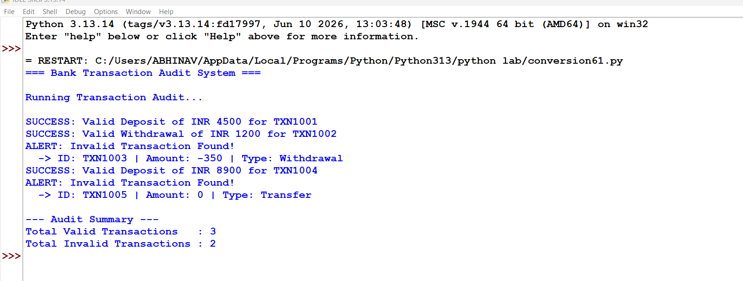

Conclusion: Successfully utilized tuple unpacking and sequential iteration to parse financial transaction records, identify invalid entries, and flag anomalies.

